6-22-98 This file appears to have all tables and figures.
APPENDIX M

Collector Materials

Table of Contents

1. Materials App. M-1
1.1 Semiconductor Silicon 1
1.1.1 General Techniques 1
1.1.2 Si by INAA: Literature values 2
1.1.3 INAA Analyses 4
1.1.5 SOS 5
1.2 Germanium 5
1.2.1 General Characteristics 5
1.2.2 Ge SIMS Analysis 5
1.3 Noble Metal Foils and Films 6
1.4 Concentrator Target Materials 7
1.4.1 Single Crystal Noble Metals 7
1.4.2 Diamonds 8
1.4.2.1 Diamond SIMS Study 9
1.4.2.2 Diamond SIMS Results: Impurities 10
1.4.2.3 Diamond SIMS Results: Diffusion 13
1.4.2.4 Diamond SIMS Study Conclusions 15
1.4.3 Comparisons between noble metals and CVD diamond 16
1.5 Materials for Noble Gas Collection 17
1.5.1 Solar Wind 17
1.5.2 Energetic Particles 18

2. Blank Measurement of Candidate Collector Materials 18

3. Summary of Future Collector Materials Work 19
3.1 Further work on Si 19
3.2 SEP Noble Gas Collector Development & Test 20
3.3 CVD Diamond Testing 20

Appendix M References 21

APPENDIX M

Collector Materials

1. Materials

Because of the rarity of most elements in the solar wind the primary requirement for the collector materials is that they have extremely low impurity levels. Since it is unlikely that any one material will have optimum characteristics for all elements and all analysis techniques, the collectors will combine several different materials. Generally speaking, analytical techniques (Appendix J), such as secondary ion mass spectrometry (SIMS) or resonance ion mass spectrometry (RIMS), that only analyze the surface layers containing the implanted solar wind have fewer materials purity difficulties than those that require bulk analysis of the entire collector thickness. For nominally bulk analytical methods such as radiochemical neutron activation analysis (RNAA), "surface stripping" techniques are required which preferentially extract the surface layer holding the implanted solar wind.

1.1 Semiconductor Silicon. Silicon is an excellent substrate for RIMS and RNAA, but not as good for SIMS because of molecular ion interferences (see Appendix J).

From the aspect of purity, by far the most promising materials are semiconductors, with the most known about silicon. For many electronics products, the presence of 5-20 ppm oxygen is desirable because it getters lithophile impurities, causing them to lose their conductivity; consequently lithophilic impurities can be tolerated to some degree. This is the case for the Czochralski (CZ) method of crystal growth, in which a crystal is pulled from a SiO2 crucible. For float-zone (FZ) growth the crystal is grown from a poly-crystalline rod by passing through an RF coil in a non-oxidizing atmosphere. The FZ method is necessary to obtain wafers of higher purity, particularly in the CNO content, but also presumably for any other elements which might be present in trace quantities in the SiO2 crucible. Recent efforts to achieve the highest purity crystals have focused on using higher purity raw materials. This was motivated by a desire to reduce concentrations of B, which is not excluded during crystallization and is one of the principal acceptor impurities. The results are quite favorable for other conductive impurities as well, with reductions of up to a factor of ten. The resistivity of the semiconductor is a general measure of its conductive impurities, and by extension, should be an indicator of overall purity. FZ Si wafers grown from normal stock typically have impurity levels of ~2000 ohm cm; those produced from ultra-high purity poly-silicon average ~18,000 ohm cm, and we have obtained material with over 50,000 ohm cm.

1.1.1 General Techniques. Table M1 gives impurity measurements made on Si wafers by techniques other than neutron activation analysis (NAA). For comparison, estimated solar wind concentrations are based on an H flux of 3 x 108 cm-2s-1 and a solar wind Si/H ratio of 1 x 10-4. Estimates of all the solar wind abundances are calculated by assuming that the relative abundance pattern is similar to CI chondrites for most nonvolatile elements (Appendix B), e.g., Anders and Grevesse (1989), and that the solar wind atoms are spread over the top 100 nm for light element targets (C, Si, Ge) and over 50 nm for heavy element targets (Pt, Au). This results in conservative solar wind abundance estimates.
Table M1 Impurities measured or attempted in float-zone silicon wafers by methods other than INAA.

Element | Source | Approx. Resistivity (Ohm-cm) | Analysis Technique | Detection Limit (cm-3) | Measured (cm-3) | Solar Wind4
B | 1 | 18,000 | PL5 | ----- | 5 x 1011 | 6 x 1011
B | 2 | 2,000 | PL | 5 x 1011 | 1 x 1012 | "
C | 2 | 2,000 | IR | 5 x 1015 | -----6 | 6 x 1017
N | 2 | 2,000 | IR | 1 x 1014 | 5 x 1014 | 2 x 1017
O | 2 | 2,000 | IR | 1 x 1014 | 1 x 1015 | 1 x 1018
Al | 1 | 18,000 | PL | 5 x 1010 | ----- | 5 x 1015
P | 2 | 2,000 | PL | 5 x 1011 | 1 x 1012 | 6 x 1014
P | 1 | 18,000 | PL | ----- | 5 x 1011 | "
As | 1 | 18,000 | PL | 5 x 1010 | ----- | 5 x 1011
Ca | 3 |  | SIMS | 1 x 1015 | ----- | 1 x 1016
1Maurits et al. (1990).
2Dreier (1990).
3Our own unpublished SIMS analyses.
4Solar wind measurement is averaged over the topmost 100 nm for a 2 year normal flux. Multiply by 10-5 to convert from cm-3/(top 100 nm) to cm-2.
5PL = Photoluminescence; IR = Infrared Spectroscopy; SIMS = Secondary Ionization Mass Spectrometry
6Where measured values are not given, the impurity is below the detection limit.

1.1.2 Si by INAA: Literature values. Instrumental neutron activation analysis (INAA) is the primary technique used by industry to determine individual elemental impurities in bulk Si. INAA is well-suited for bulk analysis, and gives results for a large number of elements at once. Its sensitivity for the electrically active metals of interest to industry is quite good. Fig. M1 shows literature INAA results from several analyses for a large number of elements. They are normalized to elemental solar wind concentrations from a 2-year fluence averaged over the top 100 nm, as above. The dashed line shows our materials purity goal of (impurity/s.w.) ≤ 0.01. It is important to note that only the filled symbols are actual measurements; open symbols (and X's) are detection limits. An upper limit below the dashed line is a significant result. An upper limit above the dashed line tells us nothing. Detection limits vary according to the neutron fluence, the size of the sample, and the counting times. For the most comprehensive study, by Takeuchi et al. (1993), a symbol is given at both upper and lower ends of the range of measurements, although nearly all of Takeuchi's lower end values are simply detection limits. In general, relatively few measurements were made above the detection limits, and most measurements of bulk impurities are below the solar wind concentration. Among these 48 elements, except for Au and As, there are no cases where the INAA results are consistently above the design goal.
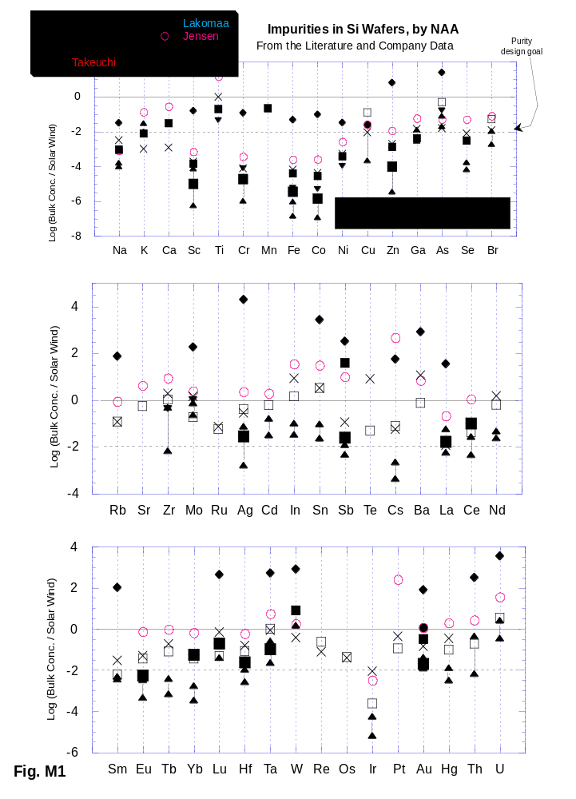

Overall, Figure M1 demonstrates why we have emphasized Si as a collector material. It should be noted that the study of Takeuchi et al., which is most useful for our purposes, did not use FZ silicon which may be higher purity. Given the requirement to measure the solar wind element fluence to an accuracy of ±5% (1σ), a very conservative purity criterion is that the background level of a given element be less than 1% of the solar wind concentration (Fig. M1 dotted horizontal line). Using this criterion, Table M2 summarizes the situation, using data from Table M1 and Fig. M1, in terms of the specific science objectives given in the Table 1 of the proposal. Elements for which there are only upper limits which are too high are omitted from Table M2.
Table M2
ELEMENTS WITH DOCUMENTED CONCENTRATIONS IN Si ≤1% OF SOLAR WIND IN AT LEAST ONE SAMPLE

General: C, N, O, Na, Al, P, K, Ca, Cr, Fe, Co, Ni, Cu, Zn, Ga, Zr, Ag, Hf, Hg, Th

A=80-90 Group: Se, Br

A=120-140 Group: Sb, Cs

REE: La, Ce, Sm, Eu, Tb, Yb

Pt-Group: Ir

ELEMENTS WITH DOCUMENTED CONCENTRATIONS IN Si >1% OF SOLAR WIND AND NO ANALYSIS ≤1%

General: B, As, Cd, In, Nd, Ta, U

A=80-100 Group: (none)

A=120-140 Group: Sn

REE: Lu

Pt-Group: Mo, W, Au

1.1.3 INAA Analyses. We are attempting to confirm the literature conclusions with our own analyses of FZ Si from known vendors. Co-investigator M. Ebihara has done several neutron activation analyses on Si crystals from two candidate vendors. In choosing materials, we have singled out FZ crystals as likely to be more desirable than CZ crystals due to the absence of contaminants leached from the CZ crucible. Of the four known foreign FZ Si producers, Topsil was used because they had the highest resistivity material and were the most helpful. Within the US, only one producer, Unisil, has recently (1994) come on line, though another producer may be in the works.

A 19 g Topsil sample (resistivity > 50 kOhm) was irradiated in 1994 at the JRR-3 reactor in site HR-2 for approximately 2 days. Estimates of the flux from co-irradiated standards give 7.1 and 7.0 x 1013 n/cm2/sec, respectively for 1173 keV and 1332 keV. The sample was cooled for 1 month before measurement at the Japan Atomic Energy Research Institute (JAERI). Before measurement, 1.2% of the material was etched away to remove surface contaminants. The counting time was 2 x 105 sec. each at distances of 0 and 5 cm from the Ge detector.

Irradiation of two additional Si crystals, one each from Topsil and Unisil, took place in 1995. This time the neutron fluence was three times the 1994 irradiation with other conditions essentially the same. Because of relatively high brehmstrahlung background (mentioned below) detection limits were only comparable to the 1994 data.

The Ebihara data are also plotted as detection limits on Fig. M1. The only element measured in the bulk sample was Au. Comparison with the literature data shows that with some exceptions Ebihara's detection limits are generally in the same range as those in the literature. Fewer elements are shown in part because only one count was done, with no attempt to measure elements with short half lives.

Dr. Ebihara’s analyses revealed a fundamental limit to bulk analysis of Si. With a moderately high flux, a significant amount of double neutron capture occurs on ³⁰Si to produce the relatively long-lived ³²Si, as illustrated in Fig. M2. Consequently, radiochemistry (RNAA) will be required to produce lower detection limits than those shown in Fig. M1.

In many cases background corrections larger than the nominal 1% would be acceptable, although this would have to be evaluated on an element by element basis, allowing for the flight materials and the analytical technique to be used.
Fig. M2 |  | 31P  100% | 32P  14.3d | 33P  25.3d
28Si  92.2% | 29Si  4.7% | 30Si  3.1%  → | 31Si  2.62h  → | 32Si  ~280a

1.1.5 SOS. Epitaxial silicon on sapphire (SOS), which is commercially available for applications where radiation hardening is desirable or where an insulator is desired for the structural backbone, was initially considered. The intrinsic electrical properties of the Si in SOS are nearly as good as FZ Si, but very little is known about individual element impurities. At present SOS remains a possible back-up material for Si wafers in the unlikely event that etching of Si wafers to catch only the top 100 nm proves too difficult. Al is an acceptable material for high flux reactor irradiation, and the sapphire is not easily etched away. The Si can be easily stripped from the sapphire substrate after irradiation, prior to gamma counting.

1.2 Germanium. While we have baselined Si for collection of solar wind, a small amount of Ge will be used for collection as well, due to its advantages for analysis by SIMS (Appendix J). However, testing the purity of Ge is much more difficult than for Si because the high neutron capture cross sections of the Ge isotopes renders NAA useless.

1.2.1 General Characteristics Hyper-pure zone-refined Ge is produced up to 7 cm diameter for nuclear detectors. This material is about as low as Si in electrical impurities, with net impurity concentrations (the difference between p-type and n-type carriers) of ~109 cm-3. Like Si, some data are available by techniques other than NAA. The best crystals have 1013-1014 cm-3 each of O and Si if grown in a silica crucible, and ~1014 cm-3 C if grown in a graphite crucible (because of its viscosity and density, it is not possible to produce Ge by the crucible-less FZ method on Earth). Of the electrically active species, typically the most abundant impurities are Al, P, B, and In, all generally below 1010 cm-3 (e.g., Haller, 1991). By comparison with Table M1, Ge is as good as or better than Si in these elements, well below the solar wind concentrations for these elements.

- Ge SIMS Analysis To check the purity of Ge, and also demonstrate sufficiently low detection limits, a SIMS analysis was carried out on two Ge samples using the PANURGE ion probe at Caltech. Elements targeted were Mg, Al, Si, Ca, Ti, Sc, Cr, Mn, and Fe, as these are common elements that have favorable sensitivity factors (RSFs) using positive secondary ions. The RSFs were taken from Wilson et al. (1989), using O₂⁺ primaries, but should be applicable for O⁻ within a factor of 2. The dark current backgrounds were 0.04-0.05 cps. The Ge matrix signal was monitored at mass 73, and ranged from 2-5 x 10⁴ cps. Charging apparently limited us from using a more intense primary beam. Mass resolution was set at M/ΔM ~ 1930, so that molecular interferences can generally be ignored.

Results are given in Table 3. Doubly charged GeO and GeO₂ did not seem to contribute any counts. Initially all of masses 24, 25, 26, 27, 28, 29, 30, 40, 44, 45, 48, 50, 52, 53, 55, and 56 were monitored, but after no unusual ratios turned up, only the major isotopes were monitored. Si was clearly measured in both samples. The mass 40 signal seemed to be Ca, as the 40/44 ratio was approximately correct for Ca. Likewise, the 25/24 and 26/24 ratios were approximately correct for Mg in the Tennelec sample. Signals at 27 and 45 were slightly above the dark current backgrounds, but it is less certain that these were actually Al and Sc.

Table M3. Purity test for two Ge samples; measurements in ppb atomic
Expected solar wind fluence, averaged over the top 100 nm, are given in the same units.
 |  | Tennelec |  | Ortec |  | Expected
Element | RSF cm⁻³ | Measured | Det. Limit | Measured | Det. Limit | Solar Wind
Mg | 6.0e20 | 3.1 | 1. |  | 1.0 | 4000.
Al | 2.0e20 | 1.5 | 0.4 | 1.2 | 0.3 | 320.
Si | 1.5e21 | 28. | 3. | 240 | 3. | 3800.
Ca | 3.5e19 | 0.2 | 0.03 | 0.3 | 0.05 | 220.
Sc | 8.0e19 | 0.2 | 0.07 | 5.6 | 0.11 | 0.13
Ti | 3.0e20 |  | 0.3 |  | 0.5 | 9.1
Cr | 2.3e20 |  | 0.3 |  | 0.5 | 50.
Mn | 5.0e20 |  | 0.4 |  | 0.6 | 36.
Fe | 1.8e21 |  | 1.7 |  | 2.6 | 3300.
Ni | 1.9e22 |  |  |  |  | 190
Rb | 2.6e19 |  |  |  |  | 0.08
Ba | 3.5e19 |  |  |  |  | 0.02

From talking to the suppliers afterwards, it appears that most of the actual measurements except for Si are probably due to low levels of instrumental contamination.

This analysis, while rather cursory, shows that Ge purity is clearly sufficient for Mg, Al, Si (1 sample < 1% of solar wind), Ca, Cr, Mn, and Fe. By comparison with Table Ge, a SIMS analysis of Si had detection limits for ~50 ppba for Ca and Ti due to interfering isobars (Appendix J). The best SIMS instruments have a factor of ~5 lower dark currents. Even with the present instrument, other elements to be tested in Ge could include F, S, Cl, Se, Br, Te, and I for negative secondaries. For positive secondaries, Ni, Rb, and Ba will be tried.

1.3 Noble Metal Foils and Films The highest purity metal foil commercially available is 99.9999% (6-9s) pure gold foil. This turns out to be not as pure as Si for most elements, but it may have some advantages. For example, because gold has only one isotope at relatively high mass, SIMS analyses will have almost no interferences (Appendix J). Like Ge, gold is also not analyzable by NAA, so less information is available on the impurities in gold. Fig. M3 shows the impurities as assayed by the manufacturer (ESPI) ratioed to the expected solar wind concentrations. Several elements are above the background. Notable is Si, which will not be measurable in Si wafers. However, Fig. M3 does not tell the whole story. SIMS analyses of foil samples revealed that many of the impurities are concentrated near the surfaces, a product of the rolling process. Therefore, it is important to use a batch of foil coming off freshly electropolished rollers; however, even this may not adequately remove particulate contamination.
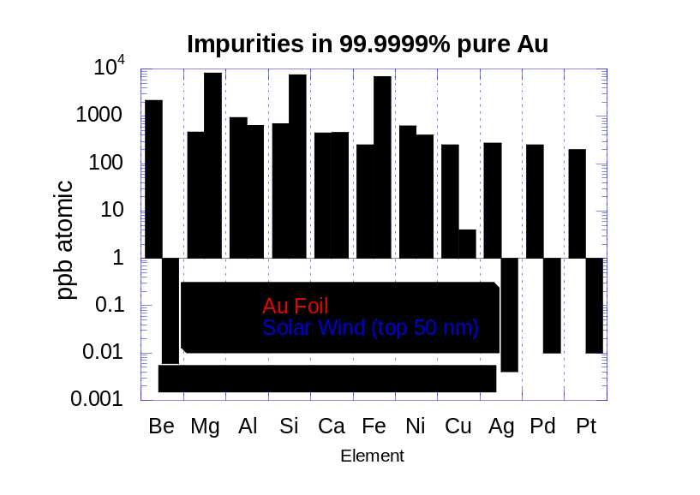
Fig. M3
Electron beam deposited Au on sputter-cleaned 6-9s Au foil could be an adequate collector material for selected elements, such as Si, light alkalis and Fe (which diffuse rapidly in Si), or S (which has high surface concentrations on polished Si wafers). The Au single crystals baselined for the concentrator target (see section 1.4.1) are too small for the large areas needed for the collector arrays. Epitaxial Au or Pt films might be ideal; however, there are problems finding an acceptable substrate. Chang (1991) has produced multilayer epitaxial films beginning with Si crystals: Cu, then Pd, then Au or Pt. This is necessary to have a suitable lattice spacing match for Au/Pt crystal growth. However, the chemical complexity of the layers is a major disadvantage. We have explored possible substrates which have a sufficiently similar lattice spacing to grow Au/Pt crystals directly Only LiF looks practical, but Li and F are both high priority elements, ruling out LiF because of the cross- contamination risk.

Because at least one other material besides Si should be used for general-purpose solar wind collection, an effort will be made in Phase B to characterize both Ge and Au foils/films to see which of these materials, if not both, should be used.

1.4 Concentrator Target Materials. As a primary requirement the concentrator target must not have a native surface oxide layer, and must have bulk oxygen concentrations lower than 1% of the expected solar wind averaged over the top 100 nm. Additionally it is desirable to have low concentrations of other light elements, particularly N, C, and F. We are considering two materials: noble metals and diamond, with diamond presently favored.

1.4.1 Single Crystal Noble Metals Grain boundaries contain the majority of all impurities in any polycrystalline material. Single crystals therefore have significantly lower oxygen impurity than foils, and also do not have the impurities (usually oxide grains) associated with rolling foils. They still can have surface impurities from the polishing process, though these are usually less than from rolling. Single crystal metals are in a cost and size range that make them suitable for the concentrator target but not for bulk collectors. We have used SIMS to analyze gold crystals in several different orientations and two different companies, and a Pt crystal. All samples were from Monocrystals except for one <100> Au crystal from ESPI; the Pt crystal had a <111> orientation. The Monocrystal Au samples were first mechanically polished and then electropolished (gold is so soft as to be difficult to polish well mechanically). The Pt crystal was mechanically polished. It had a much better looking surface, but turned out to have contamination grains buried just below the surface. The gold had some similar contamination, but not as many, and they tended to be more on the surface. Our analyses focused on finding the matrix purity and we were able to look between any such contaminants. Hence we looked for the lowest elemental concentrations within each SIMS profile.

TABLE M4 SINGLE CRYSTAL Au and Pt
Everything is an upper limit, in parts per million atomic (ppma)

 | Sample
 | Mono Au
Element | <111> | <100> | ESPI | Mono Pt | Conc SW
C | 0.69 | 0.34 | 34 | 0.54 | 250
O | 0.48 | 0.12 | 1.8 | 0.003 | 580
F | 0.02 | 0.01 |  | 0.19 | 0.021
Al |  | 0.3 |  |  | 6.2
Si | 0.042 | 0.42 | 0.63 | 0.42 | 73
S | 0.068 | 0.068 | 0.102 | 0.25 | 25
Cl | 0.26 | 2.3 | 0.2 | 4.1 | 0.13

Conditions were varied considerably over course of analysis. These are lowest measured for a given sample. UCLA Cameca 1270 analysis 8-17-95
Considerable range in detection limits, so can't conclude that ESPI less pure than Mono
Calibration factors (RSF) for Au matrix from Wilson et al., (1994)
RSF for F and Cl assumed same as Br
Elements in Pt assumed to have same RSFs as measured forAu
Al assumed to have same RSF as Au.
9-29 implant calibration for O would give lower concentrations by a factor of 2.5
Concentration factor of 20 assumed; this will be somewhat less for Al and heavier elements.
The SIMS results are shown in Table 4 for O, C, F, and several other elements. Comparison is given with the solar wind, concentrated by a factor of 20x and averaged over the top 100 nm. It is clear that the oxygen background is below the desired 1% of the solar wind, and in some cases it is much lower. Carbon is also below this goal, but F will require further study. The results are upper limits because of instrumental background (see Appendix J).

Nitrogen in single crystal Au was also analyzed by static mass spectrometry. The bulk sample had 0.63 ppma, just under the 1% design goal for blanks.

- Diamonds are the only other known material with essentially no native oxide layer and potentially low enough O (and N) concentrations. The purity levels and diffusion properties of natural diamonds have been studied for some time because of their potential for revealing information about the earth's mantle where they formed. For example, the aggregation state of nitrogen in natural diamonds has been used to study the thermal history of mantle diamonds. According to IR analyses, nitrogen diffuses very slowly in single crystal diamonds and requires high temperatures. For example, D was estimated ~ 10⁻¹⁴ cm²/s at 1900°C (Chrenko et al., 1977; see also Allen & Evans, 1981). Some other elements (e.g., helium, Wiens et al., 1994; lithium, Cytermann et al., 1994) have been demonstrated to have extremely low diffusivities in natural diamond.

CVD diamonds differ from natural diamonds in their formation process and in the fact that they are polycrystalline. CVD diamond producers have mentioned detection of a number of elements as impurities, in contrast to the relatively high purities of inclusionless type IIa natural diamonds. For species such as N and O, IR analyses can yield relative abundances of particular molecular bonds, but may not give quantitative results on the actual impurity concentration if some of the impurity has a different bond structure or is trapped in inclusions. This has motivated investigation of other methods for impurity analyses (e.g., McNamara et al. 1994).

1.4.2.1 Diamond SIMS Study. We undertook a SIMS study of CVD diamonds, both for purity levels and diffusion properties, to determine the usefulness of CVD diamonds as substrates for collecting light elements (Li-Ne) in the solar wind. The study included H implantation to simulate conditions of our solar wind target. Our results include purity constraints for F and Cl as well as N and O, and diffusivity constraints for H, N, and O.

We obtained sample diamond films from a variety of sources, including GE, Norton, DeBeers, and several university and government laboratories. All diamonds were isotopically normal (¹²C/¹³C = 89) except one sample designated “B ¹²C”, which was essentially pure ¹²C. Initial IR analyses on some of the polished samples could not detect any nitrogen.

Initial attempts to analyze diamonds by SIMS indicated that surface charging is too severe in the absence of a conductive coating for at least some of the samples. Most vapor-deposit coaters introduce moderate levels of O and other impurities, which might compromise detection-level work. To avoid this, diamond samples to be analyzed for impurities were coated in a UHV Riber MBE coater designed and used exclusively for semiconductors. Previous analysis had shown that Pt coats from this instrument had < 60 parts per million (ppm), atomic ratio, of O compared with at least several hundred ppm from typical Pt or gold coaters. The diamonds were first cleaned by ultrasonicating and heating in TCE, acetone, and isopropanol, and dried. After introduction to the MBE system, the samples were heated to 490°C for 30 minutes. The initial pressure in the chamber was 5 x 10⁻¹¹ Torr, and did not rise above 2 x 10⁻⁸ T. during heating. A 100 nm Pt coat was transferred at 0.05 nm/sec. by electron beam evaporation.

For the diffusion experiment, a polished diamond designated TD939 was implanted with the fluences and energies given in Table 5. These are the expected solar wind energies for ions passing through an electrostatic concentrator. Fluxes were below 0.3 μA/cm² in every case. Prior to implanting, the Pt coat had been removed from this sample by soaking in warm aqua regia, which caused a slight amount of surface roughness in addition to removing the Pt. Profilometry indicated surface roughness was on a scale approaching 100 nm. The sample was subsequently broken into fragments a, b, and c. Pieces a and b were vacuum sealed (≤ 10⁻⁶ Torr) in quartz glass and heated to 400 and 850 ±10°C, respectively, for 2.60 x 10⁵ s. Piece c served as an unheated control. These pieces were then gold coated in a standard vapor deposition coater, as higher impurities in the conducting coat could be tolerated in the implanted samples.

SIMS analyses were done using the Cameca IMS 1270 instrument at UCLA and an IMS 4F at Charles Evans & Associates, both run in negative secondary ion mode. In all cases, samples were kept under vacuum at least 12 hours prior to analysis. For detection limit work, the primary Cs⁺ beam current was as high as practical, ~100 nA; lower currents were used for diffusion experiments. A normal incidence electron flood gun was used to help control charging except during H analyses. The analytical area was 30 μm diameter. The C matrix counts were monitored on a Faraday cup, with everything else measured on an electron multiplier. Faraday-multiplier calibrations were performed within a day of the analyses. Hydrogen and oxygen were typically analyzed at low mass resolution (m/Δm ~ 500) since there are no expected interferences. Nitrogen was analyzed as the CN⁻ molecule at mass 27. Mass 27 had two peaks, one from ¹³C¹⁴N and one from ¹²C¹⁵N. Detection limit analyses were typically done at low mass resolution, combining the contributions from both ions. However, some samples, including an isotopically pure ¹²C diamond, were analyzed at high mass resolution (m/Δm ~ 4,000). Diffusion analyses for N were done at high mass resolution as well, monitoring both the implanted ¹⁵N and contaminant ¹⁴N.
TABLE M5. Implanted ions, listed in order of implantation
Isotope | Energy  (keV) | Fluence  (cm⁻²)
¹H | 11ª | 2.0 x 10^{16 a}
¹³C ^{b} | 72 | 1.2 x 10¹⁴
¹⁸O | 86 | 3.0 x 10¹⁴
¹⁵N | 79 | 4.0 x 10¹³
ª Implanted as 1 x 10¹⁶ cm⁻² of 22 keV H₂
^{b} Not expected to alter the matrix noticeably

1.4.2.2 Diamond SIMS Results: Impurities. Upon initial analysis using lower sputtering rates, the diamonds appeared to have consistently high concentrations of N and O, and relatively small but measurable amounts of F and Cl. However, these turned out to be instrumental artifacts. For most samples the counting rates for N and O were essentially constant, independent of the carbon matrix counting rates. Fig. M4 illustrates this point by showing a sample that did have measurable N but no measurable O or F. The analysis started with a raster size of 100 μm and a field aperture of 30 μm. After conditions equilibrated, the raster was reduced to a spot, significantly increasing the matrix counts. The N counts increased along with the C, indicating that N was from the sample. The O and F counts did not increase, indicating that these were not associated with carbon from the matrix. The source of the background is discussed below. Because this instrumental background was constant, the best detection limits were obtained with the highest possible sputtering rate, with the primary beam striking completely within the field aperture, as in the right side of Fig. M4. The background, and hence the detection limits, varied somewhat from sample to sample. What was initially thought to be Cl was actually C₂B in at least some samples, confirmed by measurement of the correct proportions for the two isotopes of boron. In other samples, the mass 35 signal did not increase with the matrix, and was therefore all instrumental background.
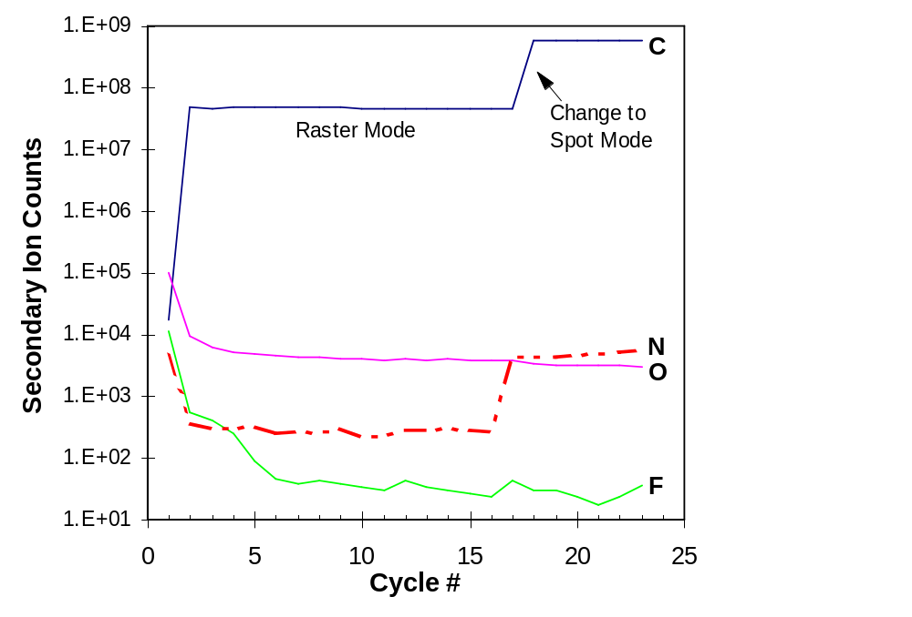
Fig. M4. SIMS analysis for impurity detection limits. The analysis was started with a primary beam raster square of 100 μm and a field aperture of 30 μm. At Cycle 17 the primary beam was switched to spot mode, so that all the primary ions struck the sample within the field aperture area, raising the carbon count rate. In this example (KMR 1146), the nitrogen signal rises with the carbon, indicating that nitrogen from the sample is above detection limits. The O and F count rates do not rise with the C, indicating that their counts are due to instrumental background.

The results for N, O, and F are shown in Table M6. Chlorine is not reported, but following the above discussion, it should be significantly below 0.05 ppm, measured at mass 35 in several samples. Note that only one sample (“G1”) had oxygen detected above the instrumental background. The lowest O limit was 1.3 ppm in samples KMR1216 and “B ¹²C”. Nitrogen was detected above background in KMR1216 and 1146, and in both of the ANL samples. The lowest N limit was 0.12 ppm. The F measurements were verified by a high mass resolution scan over mass 19, which confirmed the existence of a single peak at the proper mass. However, like O and most N analyses, the fact that the F signal did not rise with C when the primary beam was changed to spot mode indicates that the F measured was instrumental contamination. The lowest F detection limit was 0.0025 ppm in both the “B Normal” and KMR 1216 samples.

The source of instrumental background is most likely steady state surface adsorption of volatile species on the analysis spot during analysis. This is consistent with similar N and O observations during gold analyses, in which an improvement in the vacuum pressure over more than an order of magnitude improved the detection limit by approximately the same factor. The reason for background--and therefore detection limit--variations between different diamond samples is not completely understood, though it might be explained by the smoothness of the surface and the exact conditions such as temperature and pressure within the instrument at the time of analysis. The rate of adsorption of a gas on the surface is independent of the rate at which the sample is sputtered, but dependent on the partial pressure of the gas species involved. Experiments to heat the sample during analysis are currently planned, as this should lower the fraction of gas molecules sticking to the surface.
TABLE M6. Upper limits on impurity concentrations of O, N, and
F in CVD diamonds, in parts per million (ppm), atomic ratio.
Sample | O ª | N ª | F ^{b}
B Normal | 1.7 | 0.12 | 0.0025
B ¹²C | 1.3 | 0.13 | 0.0033
G1 | ~7^{c} | 0.95 | 0.07
KMR 1216 | 1.3 | 25.^{c} | 0.008
KMR 1251 | 3.7 |  | 0.06
KMR 1146 | 1.6 | 20.^{c} | 0.0025
N TF068 | 4.1 | 0.48 | 0.062
N TD939 | 3.6 | 0.33 | 0.057
ANL 941012 | 1.5 | 7.5^{c} | 0.07
ANL 940928^{d} | 2.5 | 125.^{c} | 2.5^{c}
Solar Wind^{e} | 170 | 22 | 0.006
ª Based on implant standard, analyzed at time of sample analysis
^{b} Relative Sensitivity Factor, Wilson (1991) and CEA archived data
^{c} Actual measurement rather than upper limit
^{d} This sample was only 2 μm thick, the likely reason for high N, F.
^{e} 2-year fluence, averaged over outer 100 nm, concentrator
concentration factor = 20.

One can calculate an upper limit to the amount of signal attributable to surface adsorption from the gas phase. A pressure of 5 x 10⁻¹⁰ Torr is equivalent to 2.0 x 10¹¹ molecules/cm²/s incident on the surface. For a 30 μm field aperture, the flux is ~1.4 x 10⁶ molecules/s. Assuming a sputter yield of Y = 3 C/Cs⁺, a 100 nA primary beam would give a ratio of impurity molecule/C of 7.4 x 10⁻⁷, or 0.74 ppm. This is an upper limit because it would require all adsorbed molecules to stick until bombarded by a Cs⁺ ion, and assumes all of the gas in the chamber is the impurity being measured. Rough surfaces would result in greater surface area, and higher adsorption. Molecular oxygen (O₂) or nitrogen (N₂) would give a factor of 2 higher upper limit because there are two atoms per molecule. Qualitatively this result is in the same range as the instrumental backgrounds observed for the diamonds. Similar unpublished measurements on single crystal gold, which should have a sputter yield approximately a factor of five higher, have an ultimate detection limit a factor of ten lower than the best diamonds.

Constant gas-phase adsorption would appear to be a good explanation for the background, provided that the sample area struck by the primary ions is always larger than the field aperture, so that the measurement always covers the same area. If the spot mode causes the primary beam to strike an area smaller than the field aperture, the effective measurement area would be reduced, and the adsorbed gas contribution should be reduced along with it. Typical primary ion beam diameters are ≤ 10 μm FWHM, smaller than the 30 μm field aperture. However, it is conceivable that in spot mode, the beam is intense enough that the fringes extend to the edge of the field aperture, so that the effective area, in terms of sputtering adsorbed species, is not reduced significantly.

1.4.2.3 Diamond SIMS Results: Diffusion. Implant profiles for N, O, and H in the unheated and heated pieces of TD939 are compared in Figs. M5, 6, and 7. The shoulders near the surface are predominantly due to the Au conductive coat. Concentrations are ratioed to C, which is low in the coat relative to the diamond matrix, while N and O are higher in the Au than the diamond. In Fig. 5 the geometric means of two to three profiles are plotted for each temperature. Reproducibility is discussed below. For N and O, the backgrounds were subtracted from the ¹⁵N and ¹⁸O profiles using the ¹⁴N and ¹⁶O profiles. This subtraction did not eliminate the near-surface shoulders completely because the signal was dropping so rapidly in this region that small differences in the analysis times of the individual isotopes became significant. The rising portion of the main peak matches the TRIM (IBM Theoretical Ranges of Ions in Matter) simulation well, while all of the distributions have longer tails than predicted by TRIM, due to channeling within individual crystals.
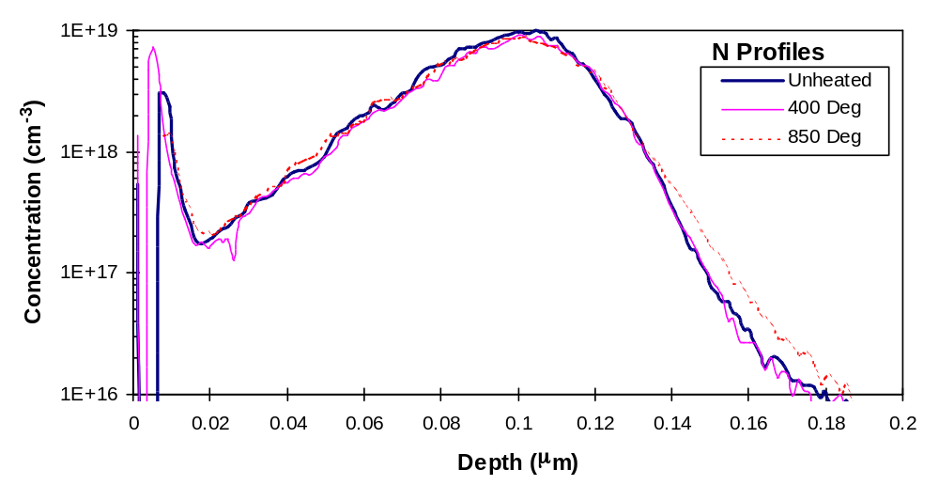 Fig. M5. Unheated and heated ¹⁵N implant profiles measured by SIMS, displayed on a logarithmic scale. Within uncertainty, there is no evidence of diffusion over the 2.60 x 10⁵ s heating. Each curve is the geometric mean of several profiles.

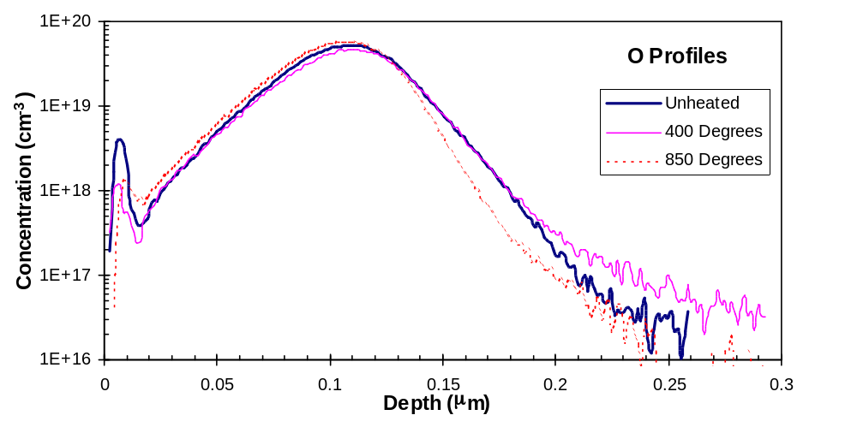Fig. M6. Unheated and heated ¹⁸O implant profiles.

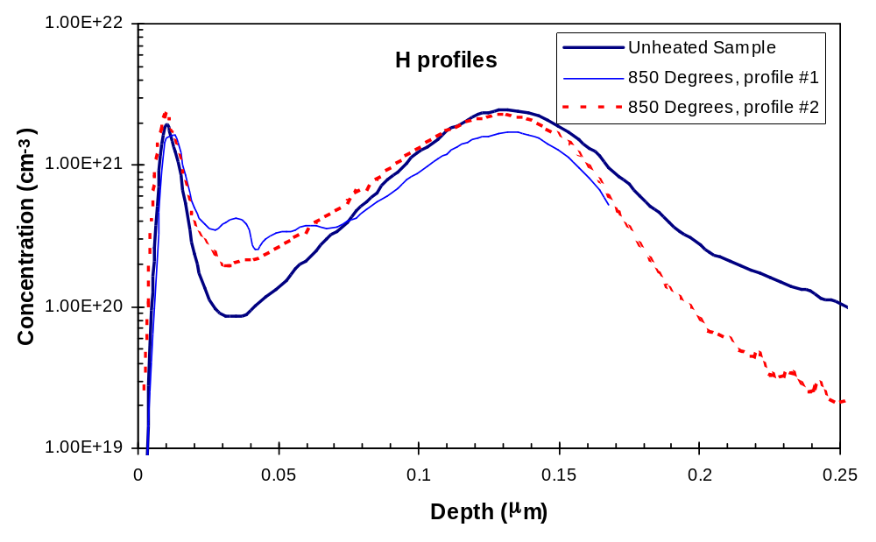
Fig. M7. Unheated and heated H implant profiles. The profiles are identical within uncertainty.

The important point to note is that the heated and unheated profiles are identical within the limits of expectation with a slightly rough surface. Diffusion would cause an increase in the dispersion around the mean, given by
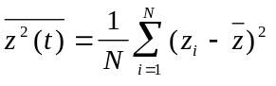 (1)
For a gaussian distribution, the diffusivity D is given by
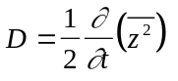 (2)
that is, D equals one half the change in the dispersion divided by the time it was held at the temperature of interest. Values so obtained are given in Table M7 using all measurements within 50% of the peak. If data down to 10% of the peak are used, D values are in the same range to slightly larger, but as can be seen from Figs. 5-7, still show no evidence of diffusion. Negative D values in Table 7 are of course physically meaningless, but give a measure of the spread in values. Conservative upper limits on the actual diffusivities are given by the largest D values, which are D_{N} ≤ 8.4x10⁻¹⁹, D_{O} ≤ 1.6x10⁻¹⁹, and D_{H} ≤ 4.6x10⁻¹⁸ cm²/s. Note that for some of these, notably O and H the largest D values are at 400°C, while at 850° the values were lower, showing that the actual diffusivity is very likely much lower than could be measured in this experiment.

Diffusion: Solar Wind Applications. For the purpose of solar wind collection, it is important to know whether the elements of interest (N, O, Ne, Li, etc.) diffuse in CVD diamond at temperatures up to 200°C. Since we determined only upper limits on diffusivity at 400°C and 850°C, it is not possible to estimate D(200°) from an Arrhenius plot. Instead, a most conservative approach would be to say that an upper limit is given by the upper limits determined at 400 and 850°C. This is ~5 x 10⁻¹⁸ cm²/s. Over an exposure period of approximately two years, this would lead to a characteristic diffusion length of sqrt(4Dt) = 23 nm. This is smaller than the concentrator target’s 100 nm depth for the implantation peak, but it is possible that the atoms will only need to diffuse to a grain boundary before they can escape.
Table M7. Calculated values for D ob-
tained from profile dispersions, relative
to an unheated sample.
Element,  Profile # | Temp. (°C) | D (cm²/s)
N #1 | 400 | -2.2e-19ª
#2 |  | 9.9e-21
#3 |  | 5.7e-19
N #1 | 850 | 4.6e-20
#2 |  | 8.4e-19
#3 |  | -2.7e-19
O #1 | 400 | 2.1e-20
#2 |  | 1.6e-19
O | 850 | -2.2e-19
H | 400 | 2.3e-19
H #1 | 850 | -5.2e-19
#2 |  | 2.2e-20
ªNegative values are physically meaning-
less, but are included to show the spread
in calculated values.

More realistically, Chrenko et al. estimated D ~ 10⁻¹⁴ cm²/s for N in diamond at 1900°C. Using this value and our upper limit at 850°C, one can extrapolate a diffusivity upper limit of 2 x 10⁻²⁷ cm²/s, which translates to less than a fraction of an Angstrom in two years. One can also use estimates of the activation energy for nitrogen in diamond, based on the changes of IR spectra as a function of heating. One is from Chrenko et al., who estimates the activation energy to be 60 kcal/mol. Using this value, and his diffusivity estimate of 10⁻¹⁴ cm²/s at 1900°C, one gets D ~ 6 x 10⁻³⁶ cm²/s at 200°, meaning that atoms are firmly held in place. It is thus expected that the actual D values for N, O in diamond are many orders of magnitude lower than we could measure.

- Diamond SIMS Study Conclusions: The oxygen and nitrogen upper limits were in at least several cases below 1% of the expected concentrated solar wind values, meeting our purity goals. In addition, F concentrations are below that expected for the concentrated solar wind. Though not shown here, S concentrations were also below 1% of the expected solar wind, which would be applicable if CVD diamond is also used as a collector for unconcentrated solar wind.

Diffusion studies indicate that solar wind-implanted N and O will be retentively held at temperatures of up to 200°C for the duration of the mission, though more studies should confirm this.

A final result of our study is that for diamond there is no detectable radiation damage from the fluence levels expected for the solar wind. This study substituted H for He, so the conclusions should be tested again, but from studies of similar He fluences and energies in metals, no damage is expected.
Table M8. Ranges, trapping efficiencies, and concentrations for diamond vs. noble metal as the concentrator target material.
Ion | Range (Angstroms) |  | Straggle (Angstroms) |  | Trapping Efficiency (%) |  | Concentration at peak (ppma)
 | Dmnd | Pt* | Dmnd | Pt | Dmnd | Pt | Dmnd | Pt
¹⁶O⁺⁶ | 850 | 430 | 175 | 470 | 100 | 80.9 | 900 | 960
¹⁶O⁺⁸ | 1060 | 545 | 203 | 560
*Pt was used in this study. Au would be essentially the same. The ion simulation program TRIM was used to determine trapping efficiencies, and the ranges and stragglings were taken from TRIM tables. Trapping efficiencies were calculated using at least 2,500 pts., giving statistical uncertainty of 2%. From the straggling parameter, along with the material densities and solar wind fluences, a concentration peak was determined. Distribution peak concentrations assume no energy spread in the solar wind, and assumes all ions are of the stated charge state. A gaussian approximation is used; Monte Carlo calculations indicate that most peaks are higher, some by as much as 28%, than the gaussian approximation. Assumed O fluences are 7.5 x 10¹⁴ cm⁻².
1.4.3 Comparisons between noble metals and CVD diamond. There are a number of differences between diamond and noble metal foils besides those mentioned above. Obviously solar wind carbon cannot be measured in a diamond matrix. This means that either diamond must be used in tandem with another material for the concentrator target, or solar wind carbon must be analyzable without concentration. Secondly, the chemistry during sample extraction differs between the two matrices. Solar wind oxygen extracted from diamond would come out predominantly as CO, greatly simplifying the procedure for GSMS of O as CO molecules (see Appendix J). On the other hand, GSMS of O as O2 may be simpler by extraction from a noble metal matrix. A disadvantage of diamond is that it is not a good electrical conductor. A diamond target would need to be very thin in order to avoid charging. Further tests will need to be done in this regard.

An important difference is that the ions are implanted quite differently in the two matrices due to the large difference in atomic number between C and noble metals. Actual ranges and straggles (standard deviations) for two charge states are compared in Table M8. Implantation in noble metal gives a relatively broad shallow peak. Approximately 20% of the ions are backscattered out of the target. This fraction is slightly dependent on atomic mass, with TRIM calculations showing approximately 5 permil/amu fractionation for oxygen of the same charge state and normal incidence. More calculations to cover the range of angles and charge states need to be done to determine the overall mass fractionation. By comparison, implantation in diamond gives a deeper peak, which makes solar wind easier to separate from surface contamination and has negligible mass fractionation.
Table M9 Concentrator Target Materials Characteristics Summary
 | Diamond |  | Noble Metals
O Purity | proven | √ | proven | √
N Purity | proven | √ | proven | √
C Analysis | no | X | proven | √
O Analysis by GSMS | as CO or O2 | ? | as O2 | ?
Surface Cleanliness | relatively good | √ | relatively poor | X
Low Diffusion | proven | √ | in testing | ?
Electrically Conductive | no | X | yes | √
Implant Depth and Straggle | ~1000 A, rel. tight | √ | ~500 A, rel. broad | X
Mass Frac-tionation by Backscattering | no | √ | yes | X

Both diamond and noble metals are matrices characterized by very low diffusion of trace elements, as was shown above for diamond.

The overall differences between diamond and noble metals are summarized in Table M9. Our present plan is to use diamond for the concentrator target. However, we have to deal with the potential charging problems. At present Au is a back-up material.

1.5 Materials for Noble Gas Collection. Metal foils are preferred for noble gases because of their history dating back to the Apollo solar wind foils experiment, along with the fact that noble gas backgrounds are typically very low in most materials. For example, the Xe blank in an off-the-grocery-shelf Reynolds Wrap foil is 0.0018 parts per trillion atomic, or 3.9 x 10-4 times the 2-year solar wind fluence averaged over the top 100 nm. The lighter noble gas blanks are even better relative to the solar wind. It turns out that the Bern foils used for the Apollo solar wind experiment have nearly the same blanks as Reynolds Wrap except for Ne, where the Bern foils are a factor of five better.

1.5.1 Solar Wind. Noble gas mass spectrometry has traditionally been a bulk analysis technique. However, even with these low blank concentrations, consuming the whole foil results in blanks that are up to a few percent of the bulk solar wind fluence. Sampling noble gases from individual types of solar wind, such as coronal mass ejections (CMEs), is a high science priority. The CME fluence could be as low as 10% of the total solar wind fluence, in which case, a blank from the whole foil would be too high. Because of this, we are planning to use laser extraction to remove only the near-surface layer rather than melting the whole foil. This may be most easily accomplished if the noble gases are implanted into a thin metal layer on a refractory substrate. The thin layer would be volatilized by a pulsed laser, leaving the substrate untouched. There are two such materials we are currently investigating: silicon on sapphire (SOS) and aluminum on sapphire (AOS). The SOS (mentioned in 1.1 above) is made from ultra-high purity starting materials. AOS has been used for low-blank Kr work for a number of years (N. Thonnard, personal communication). Samples of both materials are at C. Hohenberg's lab awaiting analysis using the laser extraction system. Aluminum is preferred due to its heritage and because Si surfaces has been reported to adsorb and hold atmospheric Xe very tightly (e.g., Garrison et al., 1988).

- Energetic Particles. Efforts are underway to collect high energy solar particles (SEP) for separate analysis. The existence of a SEP noble gas component for Ne, Kr, and Xe with a composition distinct from solar wind has been postulated for the last fifteen years, though it has never been confirmed by direct analysis in space. We have just recently added this to our list of objectives (Table 1 in proposal). It may be possible to separate SEP noble gases by stepped heating, as has been done for lunar grains. However, an unambiguous way to measure SEP would be to collect it separately in a multilayer target. Preliminary plans are for a three-layer target consisting of a 0.2 μm thin Si film deposited on a 1.0 μm thick Au foil, physically supported by a high transparency (>90%) mesh. The bottom layer would be a ~4 μm Au foil to capture ions in the > 100 keV/amu range (Table 10). To separate solar wind (< 10 keV/amu) from the intermediate (10-100 keV/amu) range, the Si thin film is removed from the 1 μm foil by an acid etch.
Table M10. Implantation ranges of
noble gases in Au foil.
E  (keV/amu) | Ne Range  (μm) | Xe Range  (μm)
10 | 0.11±0.09 | 0.12±0.06
100 | 0.83±0.29 | 1.15±0.30
1000 | 3.88±0.41 | 5.26±0.49
Range ± (1 std. dev.)
Source: TRIM

2. Blank Measurement of Candidate Collector Materials

Blank measurements of bulk purity levels of various collector materials is easier than actual solar wind measurements because bulk analysis techniques can be used. This is perhaps best exemplified by the NAA results for Si, described above. Actual solar wind analyses will be atom-limited (there will only be a certain limited number of solar wind atoms per 100 cm2 of substrate available), while the bulk purity measurements are limited only by how much material (grams, kilograms, tons) can be reasonably analyzed by a bulk analysis technique.

Besides NAA, there are several techniques which will play a significant role in material blank analyses. As well as being useful for Si characterization, these techniques will be invaluable to characterization of materials, such as Ge and Au foil, which are not amenable to NAA (cf. Appendix J). SIMS and RIMS (Appendix J) are being used to determine blanks, even though the updated analytical facilities planned for solar wind analysis are not yet available. Irradiation of materials by charged particles or by high energy photons results in the emission of characteristic X-rays that are unique signatures of the atoms present. Excitation with high energy monochromatic synchrotron radiation (SXRF) can provide data on a wide range of elements simultaneously, and is effectively a bulk analysis technique for elements heavier than Fe. Another mass spectrometry technique, which uses thermal ionization (TIMS) of material chemically dissolved and concentrated on a hot filament, can be used. Blank measurements to date in the thermal ionization lab at Cal Tech indicate that, with less than 10 g of material, the following elements can be assayed to blank levels comparable to INAA measurements: Mg, Ca, Ti, Sr, Sm, Nd, Ba. Another effective technique is inductively coupled plasma mass spectrometry (ICPMS). It can be combined with chemistry techniques to do bulk analyses of any of our collector materials. Estimated detection limits from R. Brown at Elemental Research Inc. shows that their ICPMS techniques for Si should have detection limits below the expected solar wind concentration for the following elements: Na, Mg, Al, Ca, Ti, V, Cr, Mn, Fe, Co, Ni, Cu, Zn, Ge, Ru, Y, Ba, and Pt.

3. Summary of Future Collector Materials Work

The work needed falls into three categories. 1) Further work on Si, 2) Testing of a multilayer noble gas collector to separate high energy particles from solar wind (1.5.2 above), and 3) Further testing of CVD diamond.

- Further work on Si. This is by far the broadest area of work to be done. So far we have demonstrated that materials exist in sufficient purity to accomplish six of our sixteen science objectives (Table 1 in the proposal). We plan to go down the line demonstrating the feasibility of each objective. This requires the combined efforts of RNAA, TIMS, RIMS, SIMS, and ICPMS. We have the organization in place to carry this out, and simply need the time and resources to finish. A brief summary of the strategy is given in the following paragraphs.

The A=80-90 group of elements consists of Se,Br,Rb,Sr, and Y. Literature data (Fig. M1 above) show adequate purity for Se. We plan to obtain RNAA measurements of Se. Br is more difficult, but should be possible with analysis of ^{80,82}Kr produced by reactor irradiation. Literature INAA data for Rb give an upper limit of about 0.1 times the SW value, but the geochemically similar element, Cs, is present at about 0.001 SW levels. Rb and Sr will be analyzed by thermal ionization mass spectrometry (TIMS). Y analysis by ICPMS should have detection limits below the solar wind value (R. Brown, personal communication) and we can also attempt to get a measurement by synchrotron radiation X-ray fluorescence using the high energy photons from the Argonne facility. Y is geochemically similar to the mid-heavy REE elements. Literature Si analyses for Tb and Yb are distinctly below the 0.01 limit.

The A=120-140 elements are Sn, Sb, Te, I, Cs and Ba. The literature data indicate that impurity levels of Cs and Sb are sufficiently low. Takeuchi et al report some samples with Sn concentrations at about 0.05x SW levels. As this is the least important of the A=120-140 element group, somewhat larger errors on the Sn abundance might be acceptable. RNAA measurements of Se and Te will be carried out in the future. We will attempt measurement of I by measurement of neutron capture Xe. Ba will be analyzed by thermal ionization mass spectrometry.

Literature data are available for 8 REE. Some samples analyzed by Takeuchi show light REE (La,Ce,Nd) concentrations around 0.03x SW values, but other samples with upper limits around 0.01x SW. In general our REE upper limits are about a factor of 10-50 higher than those of Takeuchi et al; the reasons for this are being investigated. If the INAA limits cannot be improved, we can use simple RNAA techniques for La, Ce, Tb, Yb, and Lu along with TIMS measurements of Nd and Sm to characterize the light REE.

The Pt-metal group of elements (Mo, Ru, Rh, Pd, W, Re, Ir, Os, Pt, Au) could be more difficult as these elements may tend to alloy with Si given the reducing conditions required to produce Si metal, and exposure to at least some of these elements occurs in the bulk Si reduction and crystal-producing processes. Although Mo, W, and Au may be too high, Ir is quite low and the Os upper limit is ≤5%. We can afford to lose a few of these elements and still test for systematic Pt-nugget fractionation in the solar nebula; in principle the Ir abundance alone can accomplish this objective.

3.2 SEP Noble Gas Collector Development & Test. We are excited about this new concept (1.5.2 above), but have not yet started actual development or testing. We need to identify the optimum combination of materials to enable us to etch off the thin film containing the solar wind, so that the much rarer SEP particles can be measured with confidence. This requires testing the uniformity and durability of the thin film to make sure it has no pinholes, and that it can remain adhered to the SEP foil after two years in space. We need to also check the structural integrity of the 1 μm intermediate range foil with a high transmission grid backing. Finally, proof of concept tests need to be made. Initial work needs to be done using ion implantation simulation software (e.g., TRIM) to check what level (n-σ) at the tail of the solar wind might get through the thin film, establishing a minimum detection for SEP particles for each noble gas. These will be compared with noble gas instrumental detection limits to see whether they are significant. Second phase proof-of-concept will involve a test in which both low energy (solar wind-like) and high energy particles are implanted, followed by analysis. For Ne both low and high energy implants can be done at Hughes, Malibu. For heavier noble gases, the higher energies will require implantation at another facility. Analysis will be done at Wash. U.

3.3 CVD Diamond Testing. We have demonstrated that some CVD diamonds have low enough blanks for solar wind N, O, and possibly F in the concentrator. At this point we need to replicate these results and verify that there is not significant variability within a given batch of diamonds. We have purchased a batch of (10) low-O CVD diamonds from GE for the purpose of doing this. As described in section 1.4.2.1 above, this involves a rather involved process of cleaning, Pt coating in a UHV MBE coater, followed by UHV SIMS analysis. It would also be very desirable to use diamond to collect Li, Be, B in the concentrator target. Most CVD diamonds contain a significant B concentration. Li is a scientifically more important (and feasible) element, but we have not yet investigated the Li impurity level in CVD diamonds, nor its diffusive properties. These will be priorities in the next couple years.

The main drawback of diamond as the concentrator target is its relatively low conductivity. CVD diamond can be made more conductive by doping, e.g., with B. However, such doping is highly undesirable because of the likelihood of contamination of other light elements as well. As discussed above, it may turn out that a thin film of diamond is sufficiently conductive so that there is no problem at all. We plan to investigate this issue in contact with diamond manufacturers.

REFERENCES

Allen B.P. and Evans T. (1981) Aggregation of nitrogen in diamond, including platelet formation. Proc. R. Soc. Lond. A 375, 93.
Anders E. and Grevesse N. (1989) Abundances of the elements: Meteoritic and solar. Geochim. Cosmochim. Acta, 53, 197-214.
Chang C.-A. (1991) Deposition of (10) Au, Ag, Pd, Pt, and Fe on (100) Si using different metal seed layers. J. Vac. Sci. Technol. A 9, 98-101.
Chrenko R.M., Tuft R.E., and Strong H.M. (1977) Transformation of the state of nitrogen in diamond. Nature 270, 141-144.
Cytermann C., Brener R., and Kalish R. (1994) Diamond Rel. Mat. 3, 677.
Dreier P. (1990) High resistivity silicon for detector applications. Nucl. Meth. A288, 272-277.
Garrison D. et al. (1988) Lunar Planet. Sci. XIX, 371.
Haller E.E. (1991) Electronic properties of hydrogen-related complexes in pure semiconductors. Physica B 170, 351-360.
Jensen L., Topsil Semiconductor A/G, Copenhagen, Denmark, personal communication, (1993).
Maurits J.E.A., Flagella R.N., and Dawson H.J. (1990) The manufacture of ultra pure grade polycrystalline silicon (abstract 394). In Extended Abstracts, Fall Meeting of the Electrochemical Society, Pennington, NJ.
McNamara K.M., Scruggs B.E., and Gleason K.K. (1994) Thin Solid Films 253, 157-161.
Takeuchi T., Nakano Y., Fukuda T., Hirai I., Osawa A., and Toyokura N. (1993) Determination of trace element in a silicon single crystal. J. Radioanal. Nucl. Chem. 168, 367-376.
Wiens R.C., Lal D., Rison W., and Wacker J.F. (1994) Helium isotope diffusion in natural diamonds. Geochim. Cosmochim. Acta 58, 1747-1757.
Wilson R.G. (1991) Depth distributions and range parameters for elements implanted into single-crystal diamonds and chemically vapor-deposited polycrystal diamond films. Surf. Coatings Tech. 47, 559-571.
Wilson, R.G. (1995) SIMS quantification in Si, GaAs, and diamond--an update. Int. J. Mass Spec. Ion Proc. 143, 43-49.
Wilson R.G., Stevie F.A., and McGee C.W. (1989) Secondary Ion Mass Spectrometry: A Practical Handbook for Depth Profiling and Bulk Impurity Analysis. Wiley, New York.
Wilson R.G., Stevie F.A., Kahora P.M., Lux G.E., and Kirschbaum C.L. (1994) Secondary ion mass spectrometry depth profiling and relative sensitivity factors for elements from hydrogen to uranium implanted in metal matrices (Be, Al, Ti, Ni, W, and Au). Preprint.

